**MYSTIC MIST FANS:**

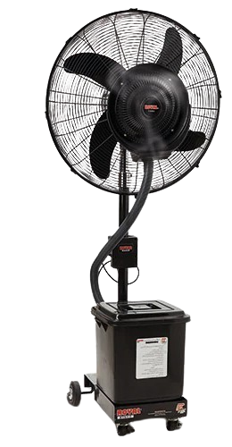

**Price: 16,300.00**

The Mystic Mist Fan is a unique and innovative cooling solution that combines a powerful fan with a fine misting system, creating a mystical aura of coolness and relaxation. With its sleek and modern design, this fan is perfect for indoor spaces, such as living rooms, bedrooms, and offices, providing a refreshing and rejuvenating atmosphere. Its energy-efficient design, adjustable misting system, and quiet operation make it an ideal choice for those seeking a cooling solution that is both functional and aesthetically pleasing.

**Key features of mystic mist fans include:**

* **Advanced Misting Technology:** Provides fine, cooling mist for temperature reduction.
* **Adjustable Fan Speed:** Allows control over airflow for personalized cooling.
* **Energy Efficient:** Uses less power than traditional air conditioning.
* **Portable Design:** Easy to move around for flexible placement.
* **Quiet Operation:** Operates quietly for minimal disruption.
* **Wide Coverage:** Typically features oscillation for even distribution of air and mist.
* **Compact Size:** Space-saving design suitable for both indoor and outdoor use.